8.29: For the truck, 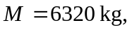and 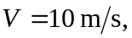 for the car, 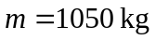 and 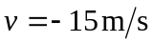 (the negative sign indicates a westbound direction).

a) Conservation of momentum requires 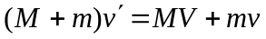, or

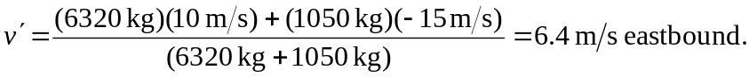

- 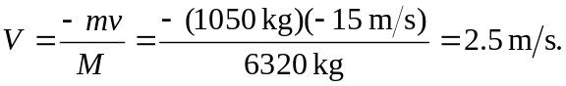
c) 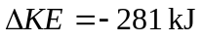for part (a) and 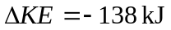 for part (b).

